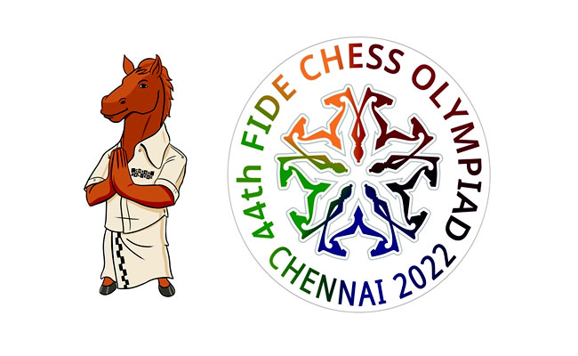
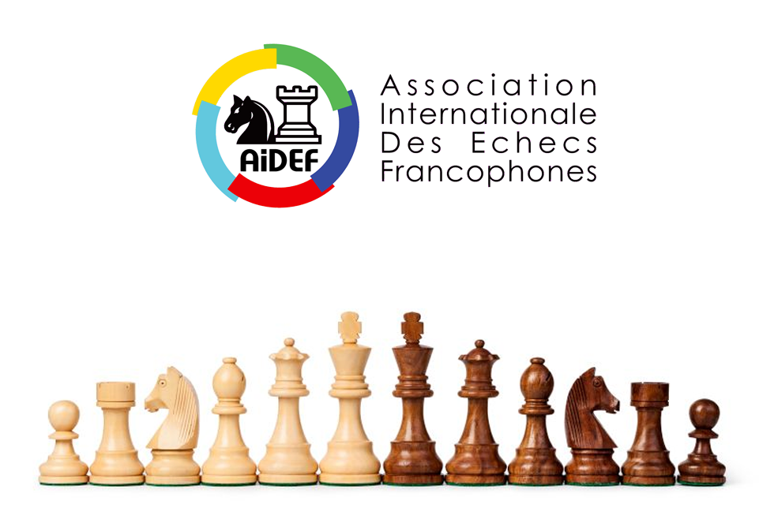
Équipes féminines des pays membres de l'AIDEF

Classement final après 11 rondes

Rg | Rg initial | FED |  | Equipe | Equipe | Parties | + | = | - | Dep.1 | Dep.2 | Dep.3 | Dep.4
1 | 2 | UKR |  | Ukraine | UKR | 11 | 7 | 4 | 0 | 18 | 413,5 | 30,5 | 157
2 | 3 | GEO |  | Georgia | GEO | 11 | 8 | 2 | 1 | 18 | 392 | 29 | 158
3 | 1 | IND |  | India | IND | 11 | 8 | 1 | 2 | 17 | 396,5 | 29 | 160
4 | 7 | USA |  | United States of America | USA | 11 | 8 | 1 | 2 | 17 | 390 | 31,5 | 143
5 | 10 | KAZ |  | Kazakhstan | KAZ | 11 | 8 | 1 | 2 | 17 | 352 | 28 | 149
6 | 4 | POL |  | Poland | POL | 11 | 7 | 2 | 2 | 16 | 396 | 30 | 155
7 | 6 | AZE |  | Azerbaijan | AZE | 11 | 7 | 2 | 2 | 16 | 389 | 29,5 | 156
8 | 11 | IND2 |  | India 2 | IND2 | 11 | 7 | 2 | 2 | 16 | 369,5 | 30 | 146
9 | 15 | BUL |  | Bulgaria | BUL | 11 | 7 | 2 | 2 | 16 | 361 | 29,5 | 147
10 | 8 | GER |  | Germany | GER | 11 | 8 | 0 | 3 | 16 | 344,5 | 29 | 140
11 | 12 | HUN |  | Hungary | HUN | 11 | 8 | 0 | 3 | 16 | 340,5 | 28,5 | 138
12 | 9 | ARM |  | Armenia | ARM | 11 | 8 | 0 | 3 | 16 | 333 | 28,5 | 143
13 | 18 | SRB |  | Serbia | SRB | 11 | 8 | 0 | 3 | 16 | 326 | 28 | 139
14 | 22 | SVK |  | Slovakia | SVK | 11 | 7 | 2 | 2 | 16 | 277 | 24,5 | 144
15 | 28 | MGL |  | Mongolia | MGL | 11 | 6 | 3 | 2 | 15 | 350 | 28 | 150
16 | 23 | CZE |  | Czech Republic | CZE | 11 | 6 | 3 | 2 | 15 | 318 | 26,5 | 142
17 | 16 | IND3 |  | India 3 | IND3 | 11 | 7 | 1 | 3 | 15 | 313 | 27 | 142
18 | 42 | LTU |  | Lithuania | LTU | 11 | 7 | 1 | 3 | 15 | 298 | 27 | 134
19 | 14 | CUB |  | Cuba | CUB | 11 | 7 | 1 | 3 | 15 | 293,5 | 26 | 139
20 | 17 | NED |  | Netherlands | NED | 11 | 7 | 1 | 3 | 15 | 292,5 | 25,5 | 143
21 | 13 | ESP |  | Spain | ESP | 11 | 6 | 2 | 3 | 14 | 339 | 29,5 | 136
22 | 5 | FRA |  | France | FRA | 11 | 6 | 2 | 3 | 14 | 328 | 27 | 146
23 | 20 | ROU |  | Romania | ROU | 11 | 6 | 2 | 3 | 14 | 325,5 | 25 | 150
24 | 32 | INA |  | Indonesia | INA | 11 | 7 | 0 | 4 | 14 | 324 | 28,5 | 142
25 | 19 | ISR |  | Israel | ISR | 11 | 7 | 0 | 4 | 14 | 322,5 | 26,5 | 142
26 | 30 | EST |  | Estonia | EST | 11 | 6 | 2 | 3 | 14 | 321 | 26,5 | 137
27 | 31 | PER |  | Peru | PER | 11 | 7 | 0 | 4 | 14 | 310 | 27 | 140
28 | 27 | GRE |  | Greece | GRE | 11 | 6 | 2 | 3 | 14 | 308 | 27 | 140
29 | 25 | ITA |  | Italy | ITA | 11 | 7 | 0 | 4 | 14 | 288 | 27 | 130
30 | 38 | IRI |  | Iran | IRI | 11 | 7 | 0 | 4 | 14 | 283,5 | 27,5 | 131
31 | 46 | UZB |  | Uzbekistan | UZB | 11 | 7 | 0 | 4 | 14 | 277 | 27,5 | 125
32 | 21 | ENG |  | England | ENG | 11 | 7 | 0 | 4 | 14 | 274 | 24,5 | 142
33 | 43 | CRO |  | Croatia | CRO | 11 | 6 | 2 | 3 | 14 | 259,5 | 23,5 | 136
34 | 40 | ARG |  | Argentina | ARG | 11 | 7 | 0 | 4 | 14 | 252 | 24,5 | 133
35 | 26 | SLO |  | Slovenia | SLO | 11 | 6 | 1 | 4 | 13 | 290 | 28,5 | 122
36 | 37 | AUT |  | Austria | AUT | 11 | 6 | 1 | 4 | 13 | 290 | 26,5 | 123
37 | 39 | PHI |  | Philippines | PHI | 11 | 6 | 1 | 4 | 13 | 285,5 | 27 | 130
38 | 57 | CHI |  | Chile | CHI | 11 | 6 | 1 | 4 | 13 | 285 | 27,5 | 128
39 | 36 | BRA |  | Brazil | BRA | 11 | 6 | 1 | 4 | 13 | 280,5 | 27,5 | 130
40 | 34 | SWE |  | Sweden | SWE | 11 | 6 | 1 | 4 | 13 | 279 | 26 | 136
41 | 33 | COL |  | Colombia | COL | 11 | 5 | 3 | 3 | 13 | 277,5 | 26,5 | 128
42 | 35 | AUS |  | Australia | AUS | 11 | 6 | 1 | 4 | 13 | 275 | 26 | 133
43 | 49 | BEL |  | Belgium | BEL | 11 | 5 | 3 | 3 | 13 | 261,5 | 26,5 | 124
44 | 41 | TUR |  | Turkey | TUR | 11 | 6 | 1 | 4 | 13 | 259 | 25,5 | 129
45 | 58 | VEN |  | Venezuela | VEN | 11 | 6 | 1 | 4 | 13 | 253 | 26,5 | 125
46 | 48 | NOR |  | Norway | NOR | 11 | 6 | 1 | 4 | 13 | 244,5 | 26 | 123
47 | 50 | LAT |  | Latvia | LAT | 11 | 6 | 1 | 4 | 13 | 237,5 | 23,5 | 129
48 | 29 | SUI |  | Switzerland | SUI | 11 | 6 | 1 | 4 | 13 | 236 | 24 | 128
49 | 47 | DEN |  | Denmark | DEN | 11 | 6 | 1 | 4 | 13 | 234,5 | 24 | 126
50 | 70 | ALB |  | Albania | ALB | 11 | 6 | 1 | 4 | 13 | 215 | 24 | 119
51 | 45 | FIN |  | Finland | FIN | 11 | 6 | 1 | 4 | 13 | 210,5 | 22,5 | 126
52 | 44 | EGY |  | Egypt | EGY | 11 | 5 | 3 | 3 | 13 | 208 | 22 | 120
53 | 24 | VIE |  | Vietnam | VIE | 11 | 5 | 2 | 4 | 12 | 294,5 | 24 | 143
54 | 56 | CAN |  | Canada | CAN | 11 | 5 | 2 | 4 | 12 | 286,5 | 27,5 | 129
55 | 55 | SGP |  | Singapore | SGP | 11 | 6 | 0 | 5 | 12 | 270 | 26 | 129
56 | 64 | BAN |  | Bangladesh | BAN | 11 | 6 | 0 | 5 | 12 | 257,5 | 27 | 121
57 | 63 | CRC |  | Costa Rica | CRC | 11 | 6 | 0 | 5 | 12 | 251 | 26,5 | 118
58 | 54 | MEX |  | Mexico | MEX | 11 | 6 | 0 | 5 | 12 | 243,5 | 23,5 | 127
59 | 51 | IRL |  | Ireland | IRL | 11 | 6 | 0 | 5 | 12 | 235,5 | 26,5 | 116
60 | 85 | UAE |  | United Arab Emirates | UAE | 11 | 5 | 2 | 4 | 12 | 221,5 | 25,5 | 115
61 | 52 | MAS |  | Malaysia | MAS | 11 | 6 | 0 | 5 | 12 | 217,5 | 22,5 | 120
62 | 71 | MKD |  | North Macedonia | MKD | 11 | 6 | 0 | 5 | 12 | 201 | 22 | 120
63 | 59 | POR |  | Portugal | POR | 11 | 6 | 0 | 5 | 12 | 192 | 22 | 116
64 | 72 | SCO |  | Scotland | SCO | 11 | 6 | 0 | 5 | 12 | 190,5 | 22,5 | 114
65 | 82 | IRQ |  | Iraq | IRQ | 11 | 6 | 0 | 5 | 12 | 174 | 21 | 117
66 | 53 | MDA |  | Moldova | MDA | 11 | 5 | 1 | 5 | 11 | 264 | 26,5 | 123
67 | 74 | NZL |  | New Zealand | NZL | 11 | 5 | 1 | 5 | 11 | 247 | 27 | 115
68 | 65 | ECU |  | Ecuador | ECU | 11 | 4 | 3 | 4 | 11 | 242,5 | 23,5 | 129
69 | 79 | KGZ |  | Kyrgyzstan | KGZ | 11 | 5 | 1 | 5 | 11 | 242 | 26 | 117
70 | 62 | ALG |  | Algeria | ALG | 11 | 5 | 1 | 5 | 11 | 225,5 | 24,5 | 119
71 | 66 | MNE |  | Montenegro | MNE | 11 | 5 | 1 | 5 | 11 | 224 | 22,5 | 126
72 | 60 | BOL |  | Bolivia | BOL | 11 | 4 | 3 | 4 | 11 | 217 | 23 | 121
73 | 99 | KEN |  | Kenya | KEN | 11 | 5 | 1 | 5 | 11 | 211 | 25 | 111
74 | 69 | ANG |  | Angola | ANG | 11 | 5 | 1 | 5 | 11 | 210,5 | 23,5 | 117
75 | 76 | ESA |  | El Salvador | ESA | 11 | 5 | 1 | 5 | 11 | 209 | 23 | 117
76 | 94 | ZIM |  | Zimbabwe | ZIM | 11 | 5 | 1 | 5 | 11 | 203,5 | 24,5 | 111
77 | 95 | HKG |  | Hong Kong | HKG | 11 | 5 | 1 | 5 | 11 | 197 | 23,5 | 112
78 | 80 | TJK |  | Tajikistan | TJK | 11 | 4 | 3 | 4 | 11 | 195,5 | 23,5 | 113
79 | 61 | ISL |  | Iceland | ISL | 11 | 5 | 1 | 5 | 11 | 194 | 22 | 119
80 | 91 | PAN |  | Panama | PAN | 11 | 3 | 5 | 3 | 11 | 193,5 | 22 | 111
81 | 104 | THA |  | Thailand | THA | 11 | 5 | 1 | 5 | 11 | 189,5 | 22 | 110
82 | 83 | SYR |  | Syria | SYR | 11 | 5 | 1 | 5 | 11 | 188 | 22,5 | 115
83 | 97 | SRI |  | Sri Lanka | SRI | 11 | 5 | 1 | 5 | 11 | 175 | 21 | 111
84 | 84 | MNC |  | Monaco | MNC | 11 | 5 | 1 | 5 | 11 | 174 | 21,5 | 110
85 | 87 | ZAM |  | Zambia | ZAM | 11 | 4 | 3 | 4 | 11 | 169,5 | 21,5 | 111
86 | 90 | WLS |  | Wales | WLS | 11 | 5 | 1 | 5 | 11 | 162 | 19,5 | 107
87 | 86 | PUR |  | Puerto Rico | PUR | 11 | 5 | 1 | 5 | 11 | 159,5 | 21 | 110
88 | 98 | KOR |  | South Korea | KOR | 11 | 5 | 1 | 5 | 11 | 152,5 | 21 | 101
89 | 96 | JAM |  | Jamaica | JAM | 11 | 5 | 1 | 5 | 11 | 150 | 20,5 | 109
90 | 67 | PAR |  | Paraguay | PAR | 11 | 4 | 2 | 5 | 10 | 201 | 21,5 | 124
91 | 93 | UGA |  | Uganda | UGA | 11 | 5 | 0 | 6 | 10 | 200,5 | 22 | 113
92 | 68 | NGR |  | Nigeria | NGR | 11 | 4 | 2 | 5 | 10 | 177,5 | 20,5 | 115
93 | 115 | TUN |  | Tunisia | TUN | 11 | 3 | 4 | 4 | 10 | 173 | 21,5 | 105
94 | 101 | NEP |  | Nepal | NEP | 11 | 4 | 2 | 5 | 10 | 171 | 21,5 | 98
95 | 78 | NCA |  | Nicaragua | NCA | 11 | 5 | 0 | 6 | 10 | 170,5 | 22,5 | 107
96 | 110 | PLE |  | Palestine | PLE | 11 | 4 | 2 | 5 | 10 | 166 | 21,5 | 103
97 | 77 | URU |  | Uruguay | URU | 11 | 5 | 0 | 6 | 10 | 161 | 20 | 114
98 | 113 | ETH |  | Ethiopia | ETH | 11 | 4 | 2 | 5 | 10 | 160 | 22,5 | 101
99 | 102 | AND |  | Andorra | AND | 11 | 5 | 0 | 6 | 10 | 158,5 | 19,5 | 106
100 | 81 | RSA |  | South Africa | RSA | 11 | 5 | 0 | 6 | 10 | 157 | 19,5 | 118
101 | 88 | BOT |  | Botswana | BOT | 11 | 4 | 2 | 5 | 10 | 155,5 | 19 | 110
102 | 89 | GUA |  | Guatemala | GUA | 11 | 4 | 2 | 5 | 10 | 148,5 | 19 | 111
103 | 121 | MAW |  | Malawi | MAW | 11 | 4 | 2 | 5 | 10 | 144,5 | 19 | 94
104 | 105 | SUR |  | Suriname | SUR | 11 | 5 | 0 | 6 | 10 | 143,5 | 20 | 102
105 | 92 | JPN |  | Japan | JPN | 11 | 4 | 2 | 5 | 10 | 143,5 | 19,5 | 100
106 | 108 | OMA |  | Oman | OMA | 11 | 4 | 2 | 5 | 10 | 143 | 20,5 | 97
107 | 117 | TTO |  | Trinidad & Tobago | TTO | 11 | 4 | 2 | 5 | 10 | 139 | 20,5 | 95
108 | 134 | SWZ |  | Eswatini | SWZ | 11 | 5 | 0 | 6 | 10 | 137 | 21 | 89
109 | 118 | KOS |  | Kosovo | KOS | 11 | 4 | 2 | 5 | 10 | 130 | 19,5 | 95
110 | 75 | DOM |  | Dominican Republic | DOM | 11 | 4 | 1 | 6 | 9 | 203,5 | 22 | 115
111 | 73 | LBN |  | Lebanon | LBN | 11 | 4 | 1 | 6 | 9 | 177 | 22 | 107
112 | 124 | TPE |  | Chinese Taipei | TPE | 11 | 3 | 3 | 5 | 9 | 167,5 | 19 | 108
113 | 111 | BAR |  | Barbados | BAR | 11 | 4 | 1 | 6 | 9 | 155 | 20,5 | 104
114 | 109 | MOZ |  | Mozambique | MOZ | 11 | 4 | 1 | 6 | 9 | 146,5 | 19 | 104
115 | 159 | KSA |  | Saudi Arabia | KSA | 11 | 2 | 5 | 4 | 9 | 138 | 18 | 94
116 | 114 | FIJ |  | Fiji | FIJ | 11 | 4 | 1 | 6 | 9 | 134 | 18 | 102
117 | 123 | NAM |  | Namibia | NAM | 11 | 3 | 3 | 5 | 9 | 134 | 17,5 | 103
118 | 103 | MAD |  | Madagascar | MAD | 9 | 3 | 2 | 4 | 9 | 126 | 17,5 | 84
119 | 107 | MLT |  | Malta | MLT | 11 | 4 | 1 | 6 | 9 | 125 | 16 | 107
120 | 136 | GUY |  | Guyana | GUY | 11 | 4 | 1 | 6 | 9 | 122 | 18,5 | 89
121 | 106 | HAI |  | Haiti | HAI | 11 | 4 | 1 | 6 | 9 | 120 | 17,5 | 103
122 | 142 | JCI |  | Jersey | JCI | 11 | 4 | 1 | 6 | 9 | 116,5 | 20 | 85
123 | 132 | KUW |  | Kuwait | KUW | 11 | 4 | 1 | 6 | 9 | 110 | 16,5 | 92
124 | 141 | MDV |  | Maldives | MDV | 11 | 4 | 1 | 6 | 9 | 110 | 15,5 | 103
125 | 119 | GUM |  | Guam | GUM | 11 | 4 | 1 | 6 | 9 | 94 | 15,5 | 94
126 | 125 | CYP |  | Cyprus | CYP | 11 | 4 | 0 | 7 | 8 | 152,5 | 21,5 | 99
127 | 135 | MRI |  | Mauritius | MRI | 11 | 4 | 0 | 7 | 8 | 140 | 22 | 89
128 | 146 | CIV |  | Cote d'Ivoire | CIV | 8 | 3 | 2 | 3 | 8 | 138,5 | 17,5 | 68
129 | 127 | LES |  | Lesotho | LES | 8 | 4 | 0 | 4 | 8 | 128,5 | 16,5 | 72
130 | 131 | PLW |  | Palau | PLW | 11 | 4 | 0 | 7 | 8 | 124,5 | 19 | 93
131 | 143 | BRN |  | Bahrain | BRN | 11 | 3 | 2 | 6 | 8 | 120 | 16 | 94
132 | 130 | SEN |  | Senegal | SEN | 11 | 4 | 0 | 7 | 8 | 115,5 | 17 | 92
133 | 144 | LBR |  | Liberia | LBR | 11 | 4 | 0 | 7 | 8 | 108 | 16,5 | 88
134 | 112 | HON |  | Honduras | HON | 11 | 4 | 0 | 7 | 8 | 107 | 16,5 | 102
135 | 122 | SUD |  | Sudan | SUD | 11 | 2 | 4 | 5 | 8 | 103,5 | 15,5 | 95
136 | 149 | BHU |  | Bhutan | BHU | 11 | 4 | 0 | 7 | 8 | 101,5 | 17,5 | 80
137 | 140 | CMR |  | Cameroon | CMR | 11 | 3 | 2 | 6 | 8 | 97 | 15,5 | 82
138 | 137 | ERI |  | Eritrea | ERI | 11 | 4 | 0 | 7 | 8 | 81,5 | 15,5 | 87
139 | 138 | TOG |  | Togo | TOG | 11 | 3 | 2 | 6 | 8 | 79,5 | 16 | 83
140 | 129 | ARU |  | Aruba | ARU | 11 | 3 | 1 | 7 | 7 | 130,5 | 19,5 | 96
141 | 139 | BAH |  | Bahamas | BAH | 11 | 3 | 1 | 7 | 7 | 126 | 18,5 | 94
142 | 128 | GHA |  | Ghana | GHA | 11 | 2 | 3 | 6 | 7 | 113 | 16,5 | 95
143 | 133 | MYA |  | Myanmar | MYA | 11 | 2 | 3 | 6 | 7 | 102,5 | 17,5 | 81
144 | 152 | COM |  | Comoros | COM | 11 | 3 | 1 | 7 | 7 | 75 | 15,5 | 77
145 | 151 | CAF |  | Central African Republic | CAF | 11 | 3 | 1 | 7 | 7 | 74 | 17 | 73
146 | 153 | DJI |  | Djibouti | DJI | 11 | 3 | 1 | 7 | 7 | 42 | 12 | 72
147 | 100 | LBA |  | Libya | LBA | 11 | 2 | 2 | 7 | 6 | 109 | 14,5 | 94
148 | 156 | LAO |  | Laos | LAO | 11 | 2 | 2 | 7 | 6 | 85 | 14 | 80
149 | 126 | CPV |  | Cape Verde | CPV | 11 | 1 | 4 | 6 | 6 | 76,5 | 14,5 | 88
150 | 147 | TAN |  | Tanzania | TAN | 11 | 3 | 0 | 8 | 6 | 75 | 13,5 | 86
151 | 161 | SOM |  | Somalia | SOM | 10 | 2 | 1 | 7 | 6 | 63 | 12,5 | 78
152 | 157 | MLI |  | Mali | MLI | 10 | 2 | 1 | 7 | 6 | 60 | 12,5 | 73
153 | 162 | SSD |  | South Sudan | SSD | 10 | 2 | 1 | 7 | 6 | 57 | 13,5 | 73
154 | 150 | BDI |  | Burundi | BDI | 11 | 2 | 2 | 7 | 6 | 54 | 11 | 80
155 | 116 | TLS |  | Timor-Leste | TLS | 11 | 2 | 1 | 8 | 5 | 80 | 13 | 91
156 | 154 | GAB |  | Gabon | GAB | 10 | 1 | 1 | 8 | 4 | 49,5 | 12 | 66
157 | 148 | SLE |  | Sierra Leone | SLE | 10 | 0 | 3 | 7 | 4 | 39 | 10 | 65
158 | 155 | GAM |  | Gambia | GAM | 8 | 1 | 0 | 7 | 3 | 29 | 7 | 64
159 | 160 | SEY |  | Seychelles | SEY | 10 | 0 | 1 | 9 | 2 | 35 | 8,5 | 70
160 | 145 | STP |  | Sao Tome and Principe | STP | 1 | 0 | 0 | 1 | 0 | 0 | 0 | 12
161 | 158 | RWA |  | Rwanda | RWA | 1 | 0 | 0 | 1 | 0 | 0 | 0 | 9
162 | 120 | PAK |  | Pakistan | PAK | 0 | 0 | 0 | 0 | 0 | 0 | 0 | 0

